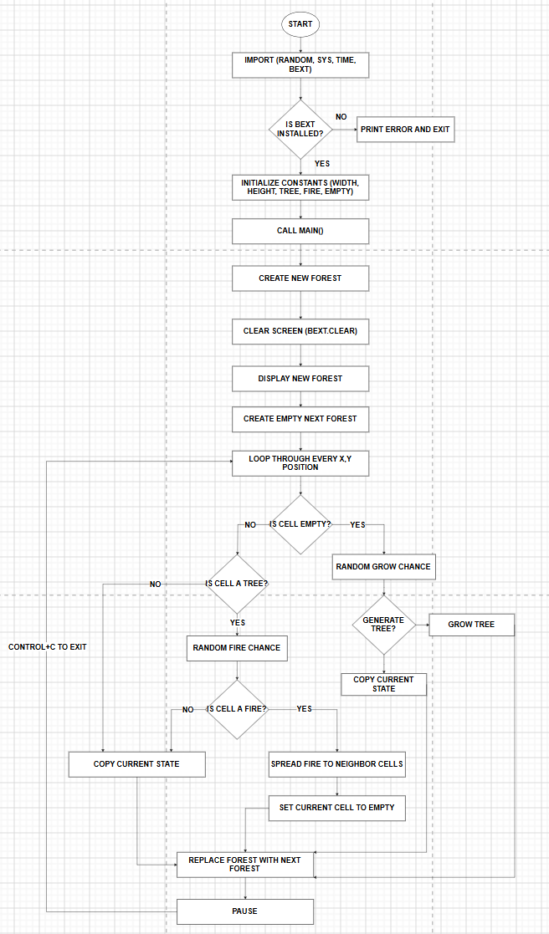
Kyle Hughes
Fred Costello
Dustin H
Anthony Garcia

CSD 325
Group C
Module 5.2

